Assignment no 1 (PLSQL)

1. Write a program that computes the perimeter and the area of a rectangle. Define
your own values for the length and width. (Assuming that L and W are the length
and width of the rectangle, Perimeter = 2*(L+W) and Area = L*W.

use Kharghar;
CREATE TABLE Area (
lengths FLOAT,
width FLOAT,
area FLOAT,
perimeter FLOAT
);
DELIMITER //

CREATE PROCEDURE rectangle(IN l FLOAT, IN w FLOAT)
BEGIN
INSERT INTO Area (lengths, width, area, perimeter)
VALUES (l, w, l*w, 2*(l+w));
END //

DELIMITER ;
CALL rectangle(5,8);

select * from Area;
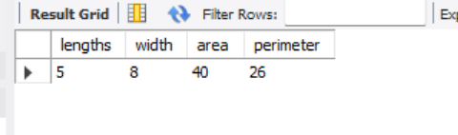
2. Write a program that declares an integer variable called num, assigns a value to it,
and computes and inserts into the tempp table the value of the variable itself, its
square, and its cube.
create table cubeandsqrt( num int, square int, cub int);
delimiter \\
create procedure cal_num(in num int)
begin
insert into cubeandsqrt(num , square , cub)
values(num , num*num, num*num*num);
end \\
delimiter ;

call cal_num(6);

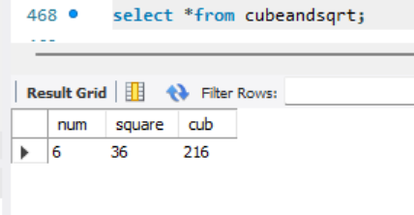

3. Convert a temperature in Fahrenheit (F) to its equivalent in Celsius (C) and vice
versa. The required formulae are:- C= (F-32)*5/9
F= 9/5*C + 32
CREATE TABLE temp_con (
num INT,
celtofar FLOAT,
faartocel FLOAT
);
CREATE PROCEDURE convert_temp1(IN num INT)
BEGIN
DECLARE cel_to_far FLOAT;
DECLARE far_to_cel FLOAT;
SET cel_to_far = (9 * num / 5) + 32;
SET far_to_cel = (num - 32) * 5 / 9;
INSERT INTO temp_con (num, celtofar, faartocel)
VALUES (num, cel_to_far, far_to_cel);
END //

DELIMITER ;

CALL convert_temp1(50);

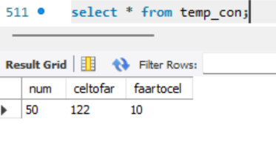

4. Convert a number of inches into yards, feet, and inches. For example, 124 inches
equals 3 yards, 1 foot, and 4 inches.
create table inche(total_inch int, yard int ,feet int ,inche int );

delimiter \\
CREATE PROCEDURE convert_inches(IN num INT)
BEGIN
declare y int;
declare f int;
declare i int;
declare rem int;

set y = num DIV 36;
set rem = num MOD 36;
set f = rem DIV 12;
set i = rem MOD 12;

insert into inche(total_inch, yard , feet ,inche)
values (num , y,f,i);
end \\
delimiter ;
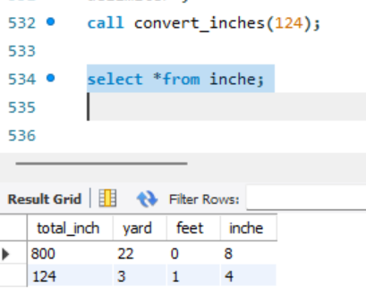

5. Write a program that enables a user to input an integer. The program should then
state whether the integer is evenly divisible by 5.
create table divcheck(num int , result varchar(40));

delimiter \\
create procedure checkdiv(in num int)
begin
declare res varchar(30);
if num MOD 5 = 0 then
set res = 'Divisible by 5';
else
set res ='Not divisible by 5';
end if;
insert into divcheck values (num, res);

end \\
delimiter ;

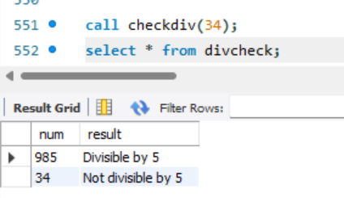

6. Your block should read in two real numbers and tell whether the product of the two
numbers is equal to or greater than 100.
CREATE TABLE productcheck (
num1 FLOAT,
num2 FLOAT,
product FLOAT,
result VARCHAR(30)
);
DELIMITER //

CREATE PROCEDURE checkproduct(IN a FLOAT, IN b FLOAT)
BEGIN
DECLARE pro FLOAT;
DECLARE res VARCHAR(30);

SET pro = a * b;

IF pro >= 100 THEN
SET res = '>= 100';
ELSE
SET res = '< 100';
END IF;

INSERT INTO productcheck VALUES (a, b, pro, res);
END //

DELIMITER ;

